1. 
2. We might have a collection with a reasonable number of requests but running and evaluating tests’ results manually is time-consuming and error prone.  
   We will look into in this section on how to optimize this approach.
3. **Section Agenda:**
   1. What we want to achieve is to run the entire collection automatically one request after another, and want to get an overview of successful or failed tests. There are multiple ways to automate things.  
      Graphical user interface, website

      Description automatically generated
4. Multiple ways to automate things  
   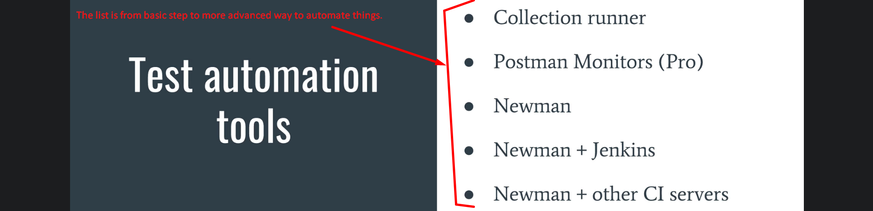
   1. **Collection Runner**:
      1. Collection runner is the first step to automation as it allows to run a series of requests with just one button click.
      2. This not only saves you time but gives a good overview of a failing test.
   2. **Postman Monitors**:
      1. Postman monitor very well integrated with Postman allows you run your collection at regular intervals.
      2. This is **Pro Feature** but still you can try this feature with free account and currently you can make **1000 API calls per month**.  
         The setup is an easy and can be accomplished within the Postman app.
   3. **Newman**:
      1. A command tool created by the same company Postman and is offered as companion product.
      2. Newman allows you to run your **tests independently of postman.**
   4. **Newman + Jenkins**:
      1. **Newman** is ideal for running tests on a **Continuous Integration Server like Jenkins.**
      2. Jenkins is **Continuous Integration Server** which has the purpose of building Software and running tests on a non-developer machine automatically every time someone pushes new code into a source repo or to build and run tests cases on a predefined schedule.
      3. We will see how **Newman** can be integrated with **Jenkins**.
   5. **Newman + Other CI Servers**:
      1. Other CI Servers such as Travis, Bamboo, Tim City, Gitlab.
      2. They all work in very similar fashion as Jenkins.
      3. Once you know how to integrate Newman with Jenkins, you can take that knowledge to integrate Newman with any other CI Server.
5. This entire section is a bit more advanced as it leaves the safe and comfortable environment of Postman and dives into the quite complex topic of continuous integration. 